Data release: Canada 1-km, 10-day, SPOT/VEGETATION composites for growing seasons 1998-2004

The NRCan/ESS Program Reducing Canada’s Vulnerability to Climate Change (RCVCC) supports a research activity committed to national scale medium-resolution EO data products for environmental and climate applications. This research activity is aimed at improvement of processing methodologies for generating consistent and comprehensive satellite records with reduced variations arising from sources such as the noise in sensor internal calibration data, geometric correction, different illumination conditions and viewing geometry, drift in satellite orbit and problems in correcting atmospheric effects.
As part of this research, data acquired by the VEGETATION 1 and 2 instruments onboard SPOT 4 and 5 satellites were systematically corrected for the period 1998-2004 following CCRS post-seasonal correction methodology. Initial data type 10-day S10 composites provided by CNES and pre-processed at VITO (Belgium) in full resolution (1km) were re-projected into standard LCC map projection and further corrected for BRDF effects and cloud contamination. Growing seasons 1998-2004 contains twenty 10-day composites from April 11, to October 31. Each composite contains four at-surface apparent reflectance bands: blue (0.43-0.47 μm), red (0.61-0.68 μm), near infrared (0.78-0.89 μm), and shortwave infrared (1.58-1.75μm) and pseudo bands NDVI and Cloud mask. This improved product are used in land cover and climate change studies to generate various high-level products such as Fraction of Photosynthetically Active Radiation (FPAR), Leaf Area Index (LAI) and crown closure.
These data are produced by a collaborative effort of the Government of Canada, Natural Resources Canada, Earth Sciences Sector and Canadian Space Agency. The VGT archive is available through GEOGRATIS at http://geodiscover.cgdi.ca/

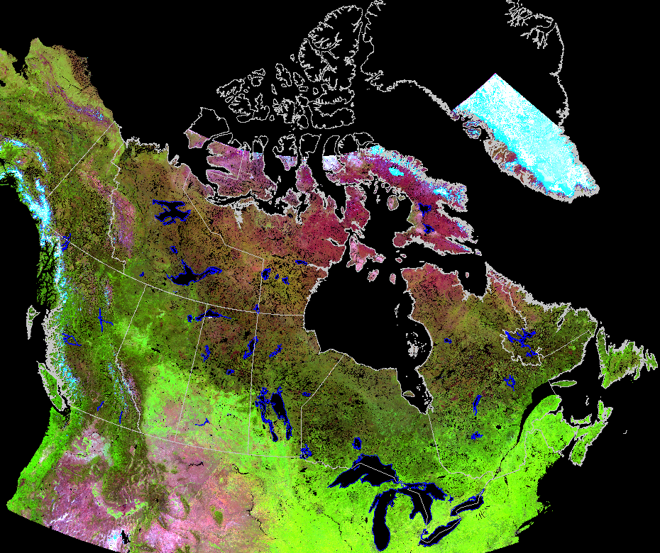
Monthly composite SPOT/VGT July 2004

For more information:
Rasim.Latifovic@NRCan.gc.ca

